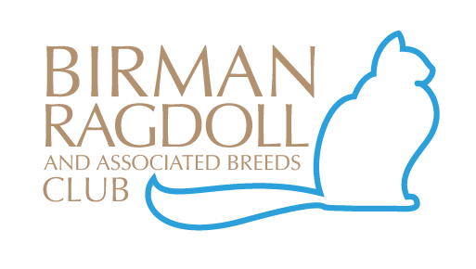

2023 MEMBERSHIP RENEWAL or APPLICATION FORM
PLEASE NOTE: SUBSCRIPTIONS ARE DUE BY
31st MARCH EACH YEAR*

Tick applicable membership type.
New membership Renewal

Mr  | Mrs  |  | Ms  |  | Miss  |  |  | Other 
SURNAME:
CHRISTIAN NAME/S |  | 1.
Joint membership 2nd person |  | 2.
DATE OF BIRTH (Junior members only) |  |  |  | Day | Month |  |  | Year
ADDRESS:
 |  | STATE: |  |  |  |  | POSTCODE:
Email:
Please print clearly
Preferred telephone number:
Web address:
Please print clearly
Breeders Prefix:
Registered Breeders must enter prefix
Current Membership of which Feline Registry Body:
As a breeder, would you like your contact details to appear on the Club web page?
Please tick your preference:  NO
Membership of other Cat Clubs/ Associations:  within Australia |  |  | 1.  2.  3.
Nominating Member:
(for new memberships only)
Signature of Nominating Member:
I agree to abide by The Code of Ethics, Constitution and Rules and Regulations as laid down by the Birman, Ragdoll and Assoc Breeds Club Inc:
Signed: |  |  |  |  | Date:
FEES:
Please send this completed form and your subscription to either:
The Secretary, Cindy Grimes at 3 Sand Drift Walk Point Cook, 3030 or by email: - birmanragdoll@gmail.com
Direct Deposit ~BSB: 033-349 ACCOUNT: 630065 Birman, Ragdoll and Assoc Breeds Club Inc.
BREEDERS Individual Membership |  |  |  |  |  | $25.00
BREEDERS Family Membership |  |  |  |  |  | $30.00
PET OWNERS Individual Membership |  |  |  |  |  | $15.00
PET OWNERS Family Membership |  |  |  |  |  | $25.00
JUNIOR Membership (12-16 years of age) |  |  |  |  |  | $10.00
*LATE RENEWAL FEE APPLIES AFTER 31ST March |  |  |  |  |  | *$10.00
 |  |  |  |  |  | TOTAL

